**COOL RUNNINGS BUILDING A PUSHCART REFLECTION ASSIGNMENT #4**

“Are We a Team?” checklist (Levin & Kent, 2001)

Check off the statements that accurately represent your group. Be prepared to discuss your choices afterwards with your group. Also consider ways to improve your group’s functioning, especially as it relates to the statements you did not check off.

This is an activity to lead you in discussion and reflection after the task is completed!

* We **ALL** show equal commitment to our objective.
* We **ALL** take part in deciding how work should be allocated.
* We are committed to helping each other learn.
* We acknowledge good contributions from team members.
* We handle disagreements and conflicts constructively within the team.
* We can give constructive criticism to one another and to accept it ourselves.
* We **ALL** turn up to class and stay engaged to the end.
* We are good at making sure that everyone knows what’s going on.
* When one of us is under pressure, others offer to help him or her.
* We trust each other.
* We remain united even when we disagree.
* We support each other to outsiders.
* We feel comfortable and relaxed with one another

**PERSONAL REFLECTION- Take Time to Answer these Questions and put into YOUR Portfolio**

Answer the following statements according to YOU being a member of your group- these ARE NOT for anyone else’s eyes!

1. A picture containing text

   Description automatically generatedHow did you feel during the activity?
2. What challenges did you face?
3. What positives can you take away from the activity?
4. What was your plan for the activity?
5. How can you apply what you learned from this activity in your life or school?
6. What advice would you give to any other team working on this activity?
7. What would you do differently next time?
8. What surprised you the most?
9. What did you enjoy about the activity?
10. What didn’t you enjoy?
11. What lessons can you learn from this challenge?
12. How well do you feel you contributed as an individual to the task?
13. What was your role?
14. Did everyone have some input?
15. Did anyone take the lead during the activity?
16. Can you have more than one team leader?
17. What is the purpose of a team leader?
18. How important was planning? Did everyone have a role during the challenge?
19. What did you learn about solving problems during the activity? How can we use this in the future?
20. Do you feel you worked well as a team?
21. How did you help your team during the activity?
22. Did the whole team agree? Did everyone have an input?
23. What did a fellow team member do that was helpful?
24. Did anyone in your team surprise you?
25. How important was the support of your team? When do we need support from others in life or the workplace?
26. How did you support others in the team?
27. 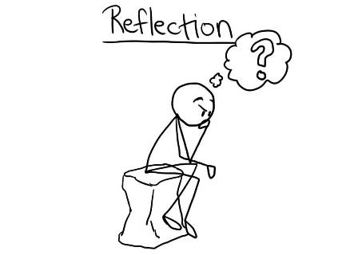Did anyone feel left out? Why?
28. What helped you or stopped you from achieving the outcomes?
29. Did you trust your team during the activity? Why was this important?
30. How did you overcome negativity in the team? Did this affect, how you approached the activity?
31. Looking back, what do feel is the most important element of teamwork?
32. How would you rate your teamwork between 1 and 10? 10 being the best value.
33. If you had to do it again, what changes would you make to the way you approach the task?
34. Think about your own personal experience in the activity, what would you do differently next time?
35. Looking back on the activity, what two things stand out to you the most and why?
36. What did you learn through this experience and how can you use it in the future?
37. Before moving on to the next challenge, I would like you to identify one area where you feel you could have contributed more.
38. What is more important the completing the activity or learning about ourselves and our team?
39. How did you support others when you found the activity difficult?
40. What did you learn about yourself and your team from any failures surrounding this task?

**“The unexamined life is not worth living.”** *Socrates*

Without self-reflection, we simply go through life without thinking, moving from one thing to the next without making time to evaluate whether things are going well. We don’t pause to think. To analyze. To determine what is going well and what isn’t working. The unfortunate result is that we often get stuck.

A lack of reflection causes us to simply keep running, trying to keep up with things even if things aren’t going well. We feel like we’re simply trying to keep our heads above water. We end up doing the same things repeatedly, even if those things aren’t producing the results we had hoped for.



Find **THREE** Websites that talk about the BENEFITS of SELF REFLECTION: What is the main message in all of them?

1

2.

3.

**MESSAGE:**

Name 5 Things that you NEED to Acknowledge about yourself:

1.

2.

3.

4.

5.