PUSH-CART TEAM SUMMARY ASSIGNMENT #4 (AS A TEAM)
Start your almost engines! In this high-speed creative event, the goal was to build and race custom people-powered push-karts. The chassis was built with individual specifications, the design team worked on a unique custom theme for the body and the crew members worked together in their various roles trying to race their way to victory lane.
Points were gained for originality, design, creativity, functionality, teamwork, and finish in the race.
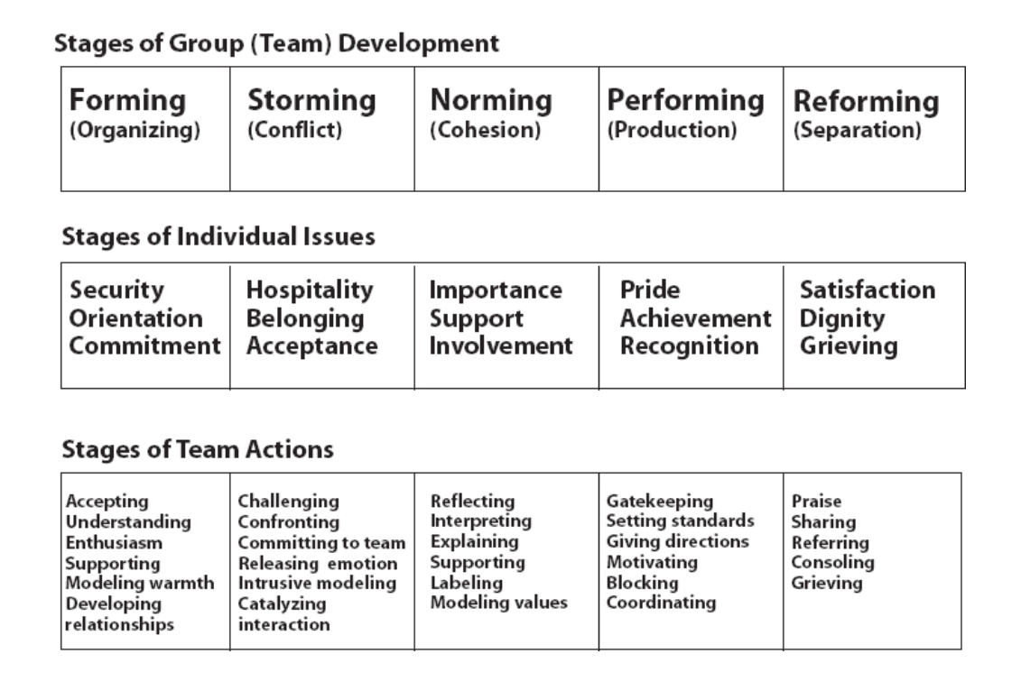
All crew members created and performed their very own “Champions’ Chant.”

Adjourning

Please Complete a SUMMARY (all of you in it!) detailing the Group Process
Using the Chart on the following page, make a detailed report of your team’s progress, process, roles, responsibility, learning moments, difficulties, group cohesion, estimated cost of materials to build your KART not including your labour, estimated time spent by each member doing their part, and what could change if you were to do something like this again with your same group.
You will present as a group to the rest of us in one of the following ways: Video, PowerPoint, Old Fashioned Bristol Board and Talk, other. Include Pictures/Videos of your teamwork, challenges, building, CHANT, and race with your Final Product.

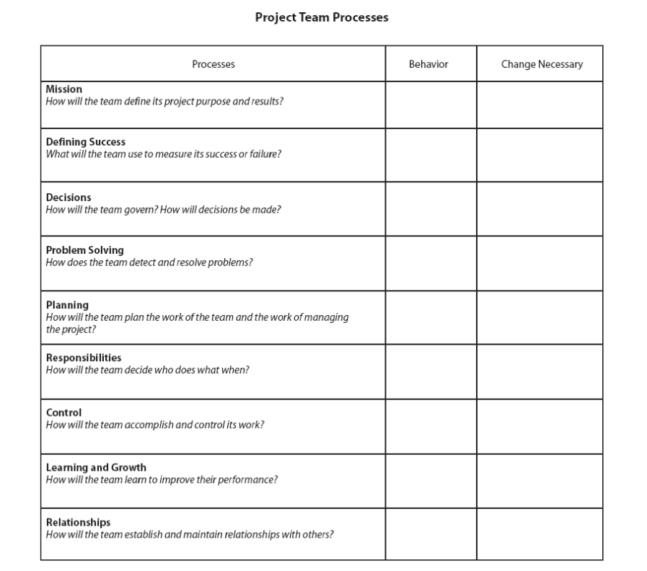
What was done?
Is Change Necessary? How/why

What was the mission or goal of your team?

Now that the race is over, how does your group measure success and or failure during and after the planning to the final race

How were decisions made on your team? Was there any conflict?

What problems developed and how were they solved? Explain

How did you plan and how well did you stick to the plans?

How did you decide who would do what and did everyone participate and pull their weight? BE HONEST WITH YOURSELVES- tough topic!

Was your group able to control the participation of its members or were certain jobs left to be done out of the teams sight?

How could your team improve if ever faced with a similar project? What could each member do!

Do you feel closer to the people in your group? Did you learn anything from them or this experience?

ALSO INCLUDE: PLANNING SHEETS, COST of ITEMS for the KART, TIME, COOPERATION, ASSISTANCE FROM OTHERS outside the class or group (all good btw), FINAL GROUP SHOT WITH THE KART!

