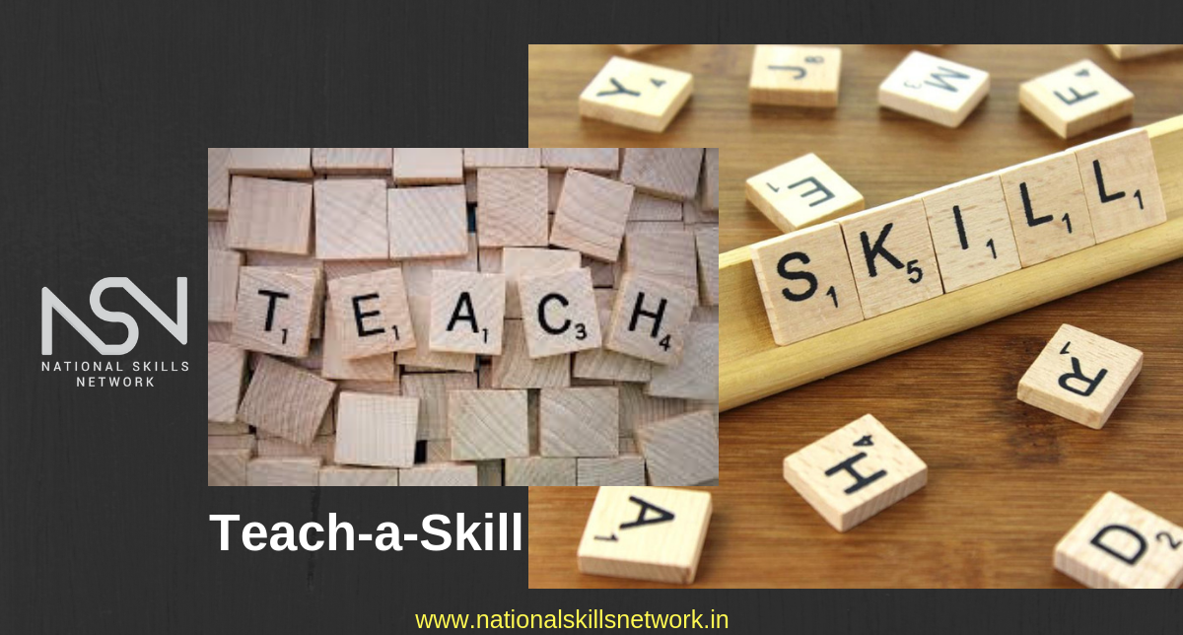

**FITNESS AND RECREATION LEADERSHIP- PLF-4M**

## **Assignment 4:** Instruct a Skill (SUMMATIVE- Formal Assignment)

There are so many skills that we have learned over the years that we take for granted!

Today you have to opportunity to work on your OWN leadership by teaching a skill that you are accomplished at to your peers.

1. You will select a skill that requires LITTLE TO NO EQUIPMENT and will not take a long time to teach. (Once it is chosen it is off the table for others to select- you must let me know)
2. You will provide any and all equipment that is required
3. You will go through the steps to teach the skills, breaking it down into smaller chunks if needed. Showing your peers what they need to do to learn the skill.

**EXAMPLES:** juggling, tying a shoe, making a pom-pom, braiding hair, calligraphy lettering, perfect push-up, knitting, shuffling a deck of cards like a dealer, speaking another language,etc. IT MUST BE A HANDS-ON or ACTIVE MOVEMENT/MIND SKILL

**EVALUATION**

What you should start doing- what could I improve on

What you should stop doing- what did not go well

What you should continue doing- what was really good about my presentation

SEE RUBRIC