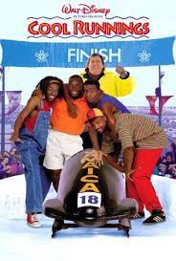
COOL RUNNINGS BUILDING A PUSHCART
There is a team of minimum 8 members.

This activity involves creating a pushcart. It is not so easy, and it is not possible for one person to do it. It needs the usage of many different parts that you can all find and or come up with, etc.
It is a perfect activity for making you learn team building.
We will use your pushcarts to race next week in the JUC Gym.
You will have one whole afternoon to construct your cart and customize it to your liking.
You will need to plan and decide what materials you will need and who is responsible for bringing them in. NOTE: this should NOT COST you a lot of money. The idea is to find things you already have in your group that you can creatively use to make your cart.
You can have access to our PHE EQUIPMENT if needed but it MUST be returned to its original state.
You should include a diagram of what you would like the cart to look like and materials needed.
All of you will be able to improve your communication with each other, enhance the spirit of teamwork, build trust and integrity for each other’s advice and work, compliance, building creativity, innovation and most importantly teambuilding.
Once your crazy creation has been built and customized to your liking, it’s time to test your vehicle where it really matters – in the PUSHCART Derby Team Trials! Your team will compete against the other teams in a series of four tests, each involving a different set of skills.
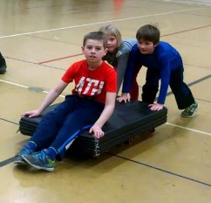
There ARE PRIZES!
- On the day of the Competitions your TEAM should look like a TEAM.
- Your CART should be operational but NOT motorized in any way.
  - Your TEAM should have a chant like in Cool Runnings “Feel the rhythm, fell the rhyme, get on up, its Bobsled time”


